**Baltimore Dynamics: Analyzing Population, crime data, and 911 Calls**

Petros Airapetyan, Carson Batchelor, Nanyi Jiang, Ben Schnoor, Yuqing Zhao

12/12/2023

Econ 695

Through the complexity of social dynamics, the relationship between population size and crime rates continues to be a primary area of study for people and policymakers throughout the world. Our white paper project explores the details of a variety of criminal behaviors, including different crime offenses based on priority levels and location. We are focusing on 911 calls, specifically in Baltimore, which has one of the highest crime rates of all cities in the United States. The connection between demographic, rate of crime calls, and crime data is something that could vastly be seen in our world today. Our hypotheses serve as recommendations to the government aimed at enhancing urban safety, including initiatives such as increased police patrols in areas with high call volumes, the implementation of mental health and social services, and the adoption of data-driven policing strategies. In our project, we are going to use Python as well as ARCGIS Pro in order to combine demographic statistics and criminal data on a map, going beyond regular statistical analysis. We are currently studying a dataset that represents Police Emergency and Non-Emergency calls to 911 from 2021 to the present. This dataset includes 18 variables and contains over 3.6 million observations. Key variables in the dataset include call date time, priority, description, incident location, and police post. On top of this, we have used other datasets such as a similar dataset for New Orleans and data released by the FBI that reflect the overall crime data in Baltimore, the state of Maryland, and Nationwide for comparison. Due to the large nature of our dataset, the numbers are approximate, however show accurate portrayals of what is happening in Baltimore.

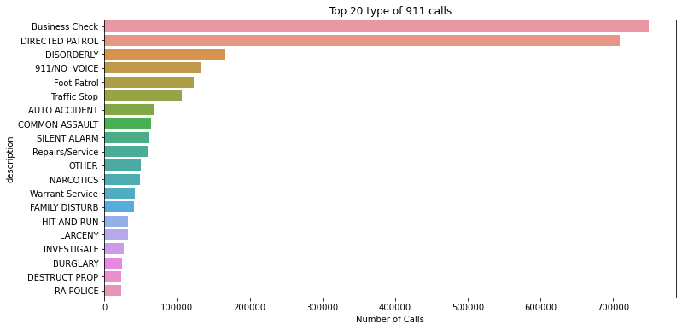

Baltimore has one of the highest crime rates in the nation, and it shows when comparing to similar cities such as New Orleans, which is similar in size and wealth. When looking at the Baltimore 911 dataset in comparison to the New Orleans 911 dataset, it can be extrapolated that Baltimore has around 15% more high priority crime than New Orleans. Now, in order to get to this conclusion, we had to jump from 911 calls to crime. As outlined later in this paper, there is a strong correlation between high priority 911 calls and crime. This leaves one issue, and that is repeat calls for the same crime. So, duplicate calls were counted as only 1 for the sake of comparing 911 calls to crime. Using “crime” per capita as the statistic to be compared, Baltimore had around 15% more crime than New orleans.

Now, looking at the basic analysis of the crime rate in Baltimore, we can see the analysis and bar graph of the type of 911 calls labeled as the description in the dataset. It creates a bar graph of the top 20 reasons people called 911 which is something that is important when looking at the different crime rate. The greatest number of calls described by the bar graph is business check and directed patrol, which are around 650,000+ calls in 2021, with their call volumes significantly surpassing other reasons for calling 911. Directed patrols are considered the hotspots of the region in which police patrol to ensure crime doesn't occur after the call. After that, it drastically goes down to disorderly conduct, which sits around 200,000 calls with foot patrol and traffic stops at around 175,000 calls. Looking at this bar graph, it seems as though there are plenty of 911 distress calls that go on in Baltimore, showing how crime is a huge factor in this city. The next graph that we are going to go over is a line graph that shows the call trends in 2021.

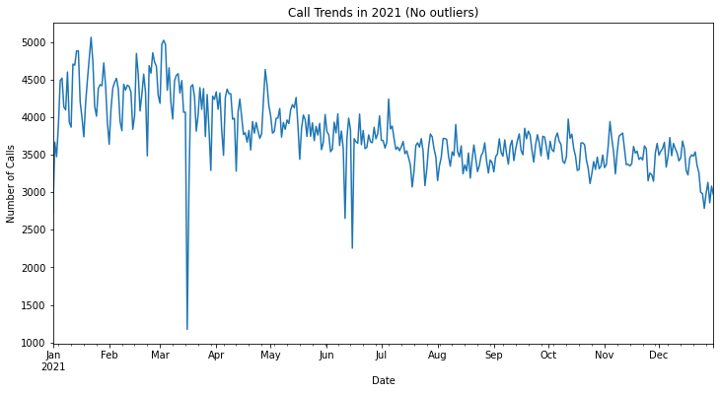

This is an analysis of the change in the total number of 911 calls throughout the specific year in the dataset. It was important to downsample the dataset while graphing so that the outliers do not have as much of an effect on the data visualization. Through the visualization of the graph, there looks to be more calls at the beginning of the year with a significant drop in the number of calls in mid-march. As the year progresses, the number of calls begins to go down. By the end of the year, there was around a 33% drop in the number of 911 calls which seems very drastic. Through the analysis, the amount of calls has gone down, but there are still questions being raised as to why there are more calls at the beginning of the year rather than the end. This is especially interesting when looking at national trends stating that most 911 calls and most crimes happen in the Summer. This is one of the things that will be addressed when giving potential solutions to Baltimore’s crime problem. 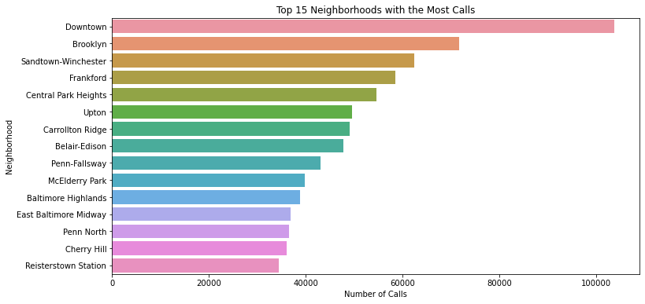

Next, this bar graph takes the top fifteen neighborhoods who have the most total 911 calls in the whole dataset. First, we have different neighborhoods within Baltimore that we could provide an overall pattern in the amount of calls that were taken. We can see that there are a little over 100,000 911 calls in downtown Baltimore that have shifted the overall change in the amount of calls. The downtown area of Baltimore appears to harbor a substantial population, contributing significantly to our comprehension of regions characterized by elevated frequencies of 911 calls. Following downtown Baltimore, there are two other neighborhoods that have over 60,000 911 calls including Brooklyn and Sandtown-Winchester. As we have seen throughout our analysis, we can see that there are more 911 calls in the more populated areas rather than the less populated areas. This was expected when identifying the correlation between population and the amount of 911 calls within that specific area of the population. The majority of the 911 calls are between 30,000 and 50,000 911 calls which can suggest that the 911 calls are made in comparison to the amount of people within the population of that certain neighborhood.

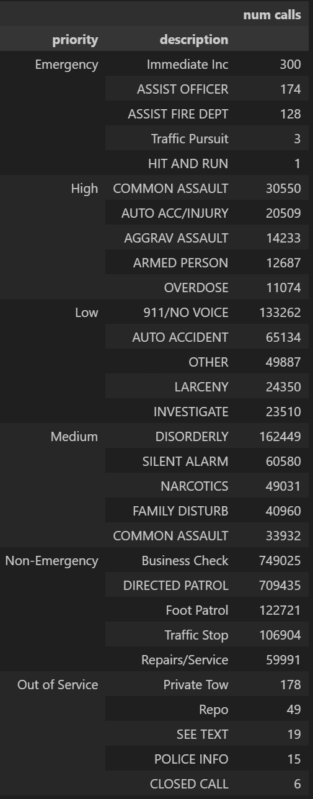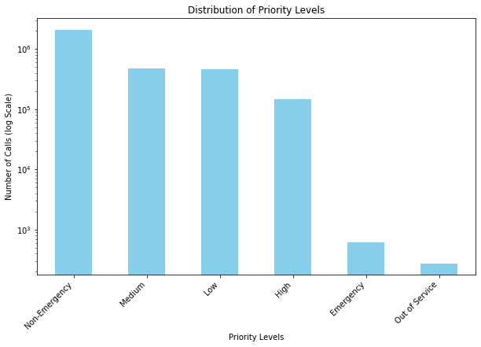

In addition, we are going to run through a deeper analysis of the 911 calls that are made in the Baltimore area beginning from the year 2021 to the present. In this aspect of our analysis, we are identifying the distribution of priority levels of the different 911 calls and relating it to the police districts within Baltimore. To begin our deeper analysis, we identify the distribution of the different priority levels in the dataset. We put this in a Log y scale so that we could better visualize the priority levels with much lower total counts. As evident, the majority of the priority levels are dominated by non-emergency calls, surpassing one million in count. The majority of the calls within the dataset are more of the non-emergency calls which shows that it could be something related to Patrol, Traffic, or stops that people may be calling about as we can see later on in the analysis. Following that, medium and low-priority calls are roughly the same sitting around 500,000 calls. These can include different types of calls such as accidents, larceny, narcotics, and assault which in turn have a plethora of calls. Throughout this, there are a lot of 911 calls in Baltimore that aren’t related to a high volume of violent crime but rather calls that are genuinely based on regular need or crime that isn’t considered violent. In addition, the high-priority calls are based on assault, hard drug use, and automobile accidents/injuries. These high-priority calls are around 100,000 911 calls which shows us that in Baltimore, there are less calls based on violent crimes, but rather crimes that are suspected to be lower priority or less violent. Emergency calls seem to be the lowest out of all which justifiably is surprising, but with the data from the dataset, we encountered that emergency calls, including assisting officers and immediate assistance, are around 1000 calls combined.

After running through this analysis of the amount of calls and the priority, we begin to see what is implied when we discuss the different priorities. This is an analysis of the type of 911 calls labeled as the description in the dataset. It is a data frame that was created to show the top 5 descriptions of 911 calls in each priority level category. As stated previously, we can see the different types of calls and the descriptions of the calls within the different priority categories. More specifically, we can see the top 5 descriptions of the different priority categories and see that the most amount of calls that we see is in the medium priority category and that is disorderly conduct. Disorderly conduct is considered anything that disturbs the peace and safety of the general public and this has the most number of calls out of any other descriptor in any priority classification. The lowest number of calls between the high, medium, and low priority calls seem to be overdosing which is at 11,074 calls. Regardless of the population, that is a lot of calls on overdosing which can then relate to the amount of drugs that are being used in Baltimore and the different crimes that are related to it. Continuing from the breakdown of call descriptions in each priority level, the analysis delves into a more granular examination by segmenting the data across different police districts. This segmentation allows for a more nuanced understanding of the specific nature of 911 calls within each priority level category.

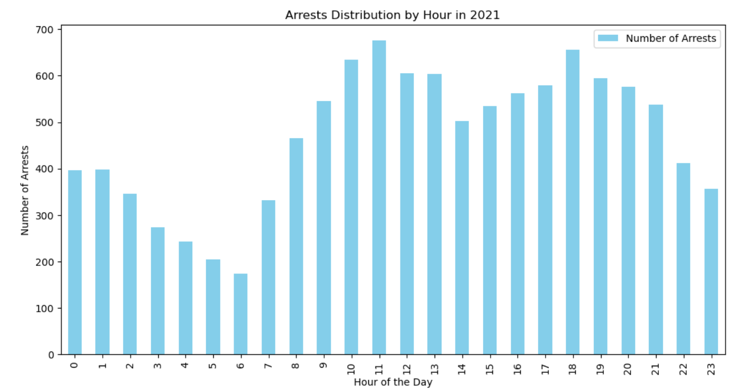

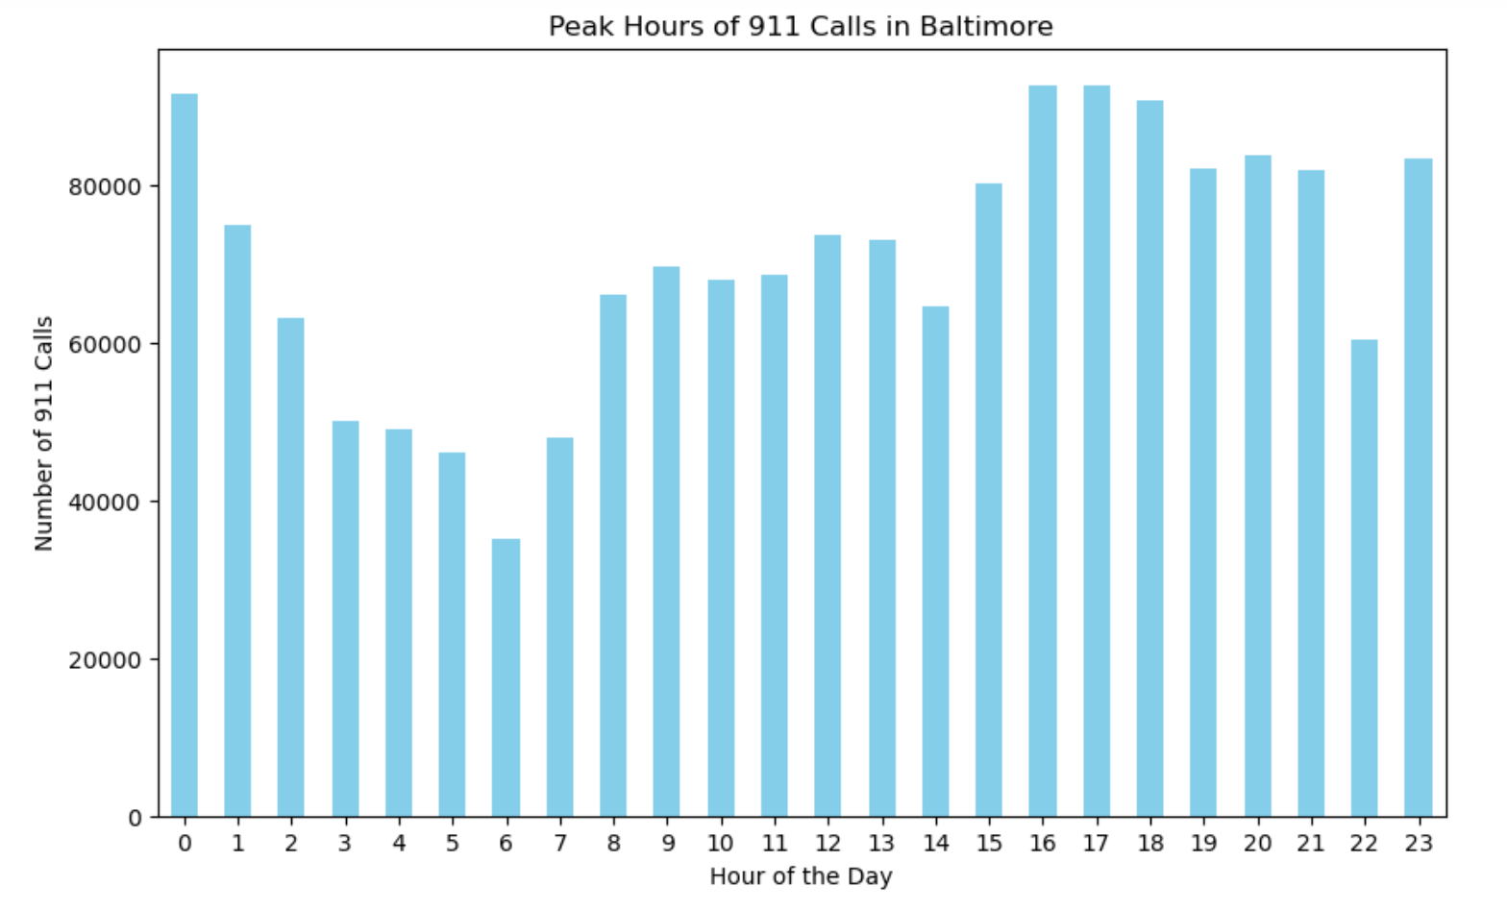The temporal patterns of emergency calls and law enforcement activities in Baltimore during 2021 reveal intricate dynamics, showcasing distinct peaks and troughs throughout the day. Analysis of the 911 call data underscores two prominent peaks, occurring in the late evening from 16:00 to 19:00 and during the late-night hours from 23:00 to 1:00. These periods exhibit an annual surge in 911 calls surpassing 85,000, indicating heightened demand for emergency services. Additionally, the timeframe from 19:00 to 21:00 demonstrates a notable frequency of 911 calls, emphasizing sustained activity and potential incidents requiring attention. Conversely, the early morning hours from 3:00 to 7:00 a.m. represent a period of relative calm with decreased 911 call frequency, possibly attributed to factors such as reduced human activity, enhanced vigilance, or fewer incidents requiring emergency assistance.

A parallel examination of arrest data from the Baltimore Police Department in 2021 further contributes to our understanding of the city's daily dynamics. The highest distribution of arrests is concentrated around 10:00-11:00 a.m. and 18:00 p.m., aligning with patterns observed in 911 calls during these hours. The lowest arrest distribution occurs from 3:00 to 6:00 a.m., mirroring the low hours of 911 calls during the same timeframe. Notably, the evening peak at 18:00 p.m. corresponds with the end of the workday, suggesting a potential correlation between post-work activities and law enforcement interventions.

The comparison of peak and low hours between 911 calls and arrests reveals intriguing connections. The late evening (23:00-1:00a.m.) and afternoon peak (16:00-19:00p.m.) for 911 calls align with the morning and evening peaks in arrests, respectively. Furthermore, both datasets consistently indicate reduced activity during the early morning hours (3:00-7:00a.m.), emphasizing a shared trend of lower public engagement and emergency incidents during this timeframe. This nuanced understanding of the temporal distribution of emergency calls and law enforcement responses in Baltimore underscores the complexity of the interplay between reported incidents and the corresponding actions of law enforcement agencies.

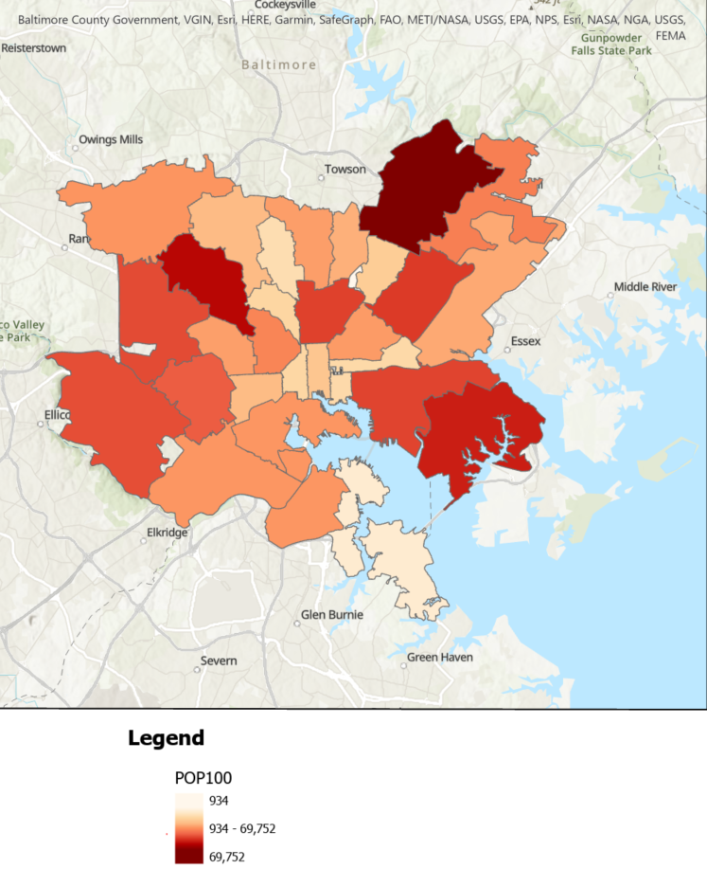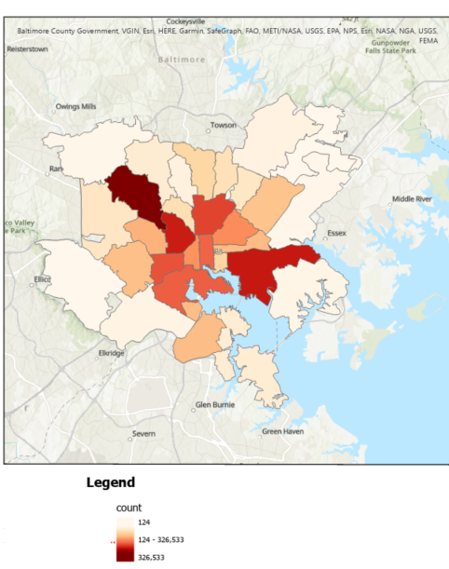

Furthermore, we dive into our ArcGIS pro analysis to understand the different types of priorities within each zip code in Baltimore. To get a good understanding of the spatial relationship that this data holds, we can create some heat maps relating to the volume of 911 calls and population. To do this the 911 data had to be edited in Python due to its volume where each 911 call per zip code was counted.

This data was joined with population data by zip code. Before looking at the maps, the hypothesis is that the more dense a population is the more 911 calls that occur per person. On the left from the previous page, is the amount of 911 calls within the different zip codes while on the right, it looks at the population of the different zip areas. The map on the left includes the darkest having a whopping 300,000+ 911 calls, although it ignores population. The second map shows the heatmap of population per zip code in Baltimore. The darker the zip code the more populated that general area is. This is a slightly deceiving map as it does not take into consideration land-area within this specified area. This then leads us into our next map created, which then takes into account the land area within Baltimore. Now normalizing for the area we can see that the crime per person is highest towards the center of the city (map on left below). These appear as the darker red colors on the map and are in more centralized zip codes. When checking 911 calls per person in each zip code (left below) we can see that since 2020, the average resident in the darkest zip code has dialed 911 around 9 times. The color similarities between this map and the population density map (right map below) shows that the more dense a population is the more 911 calls and crime there is.

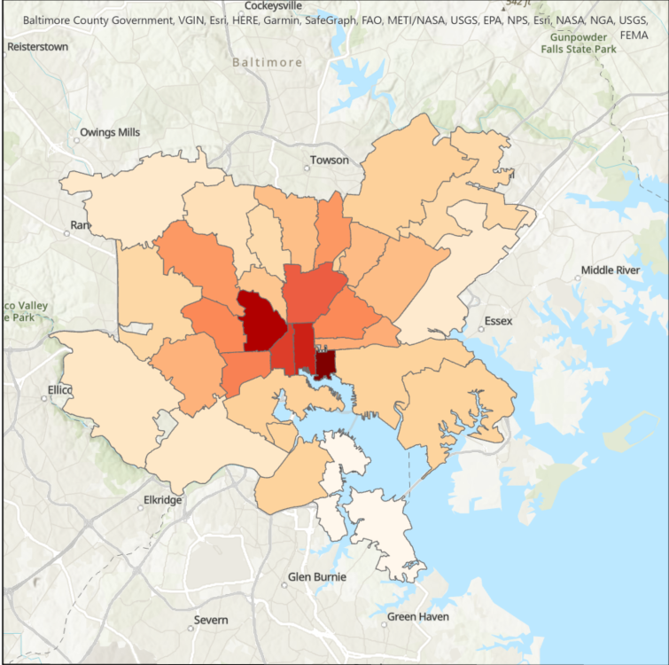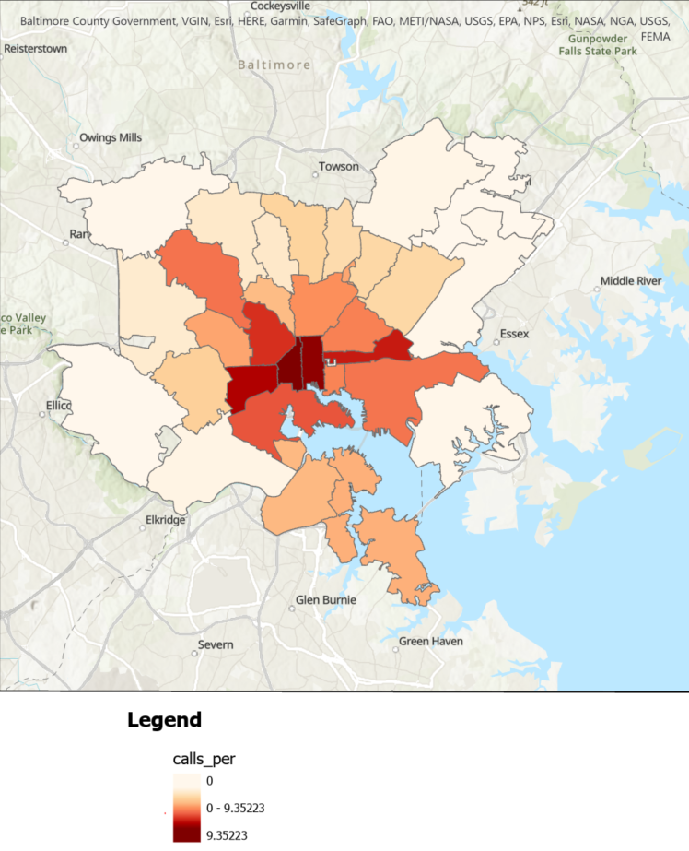

Next, we moved on to looking at actual crime and arrest data and learned that one of the largest methods of recording crime in the United States is through law enforcement reports. This data is only accurate on crimes that were reported, recorded, and not canceled. There can be a few challenges with this method however because the reports rely on getting data from all different police jurisdictions. In the past years, it appears that federal, state, and major cities have had major improvements in reporting, but many rural police departments are still a bit behind. This can be caused by several reasons such as larger cities having bigger budgets and the ability to now use digital reporting, while rural areas are less likely to be digital and still may use manual reporting techniques. Even the FBI and other large bureaus have a finite amount of resources and tracking down small rural statistics can easily be overlooked. Another issue with these law enforcement records is that officers and departments do a poor job of reporting crime that is less severe. A lot of petty theft, abuse, and other lesser crimes may be reported to begin with but later dropped causing it to not be accurate in data.

After examining the arrest data in Baltimore from 2010 to 2022, many key demographic patterns and crime statistics came into light that complements our broad analysis of 911 calls. First of all, the total number of arrests in Baltimore was 367,860 throughout the years of 2010 and 2022. The number of arrests of people under the age 20 was 28,534, indicating a notable presence of young adults and kids in the arrest data but not the largest portion. People aged 20 to 35 accounted for a significant majority, with 205,229 arrests which represents well over half of the total arrests. Furthermore, those between the ages of 35 and 50 comprised 97,059 arrests, which is still a large amount but is less than half of the previous age group. Lastly, individuals older than 50 accounted for 37,038 arrests which displays how it is the young and middle-aged adults that commit the most crime. 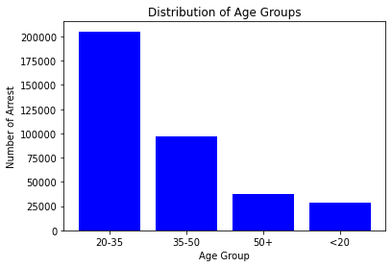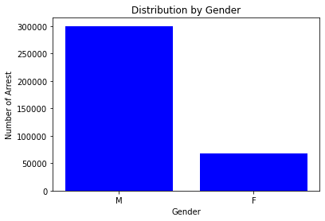

Next, after doing some gender analysis, we found a very large disparity between men and women in the arrest data with 300,313 of the arrests being men compared to 67,511 women arrested. This 4 times difference shows a potential gender related pattern in criminal behavior and law enforcement interactions.

Lastly, after doing analysis on the FBI crime data of Baltimore, the state of Maryland, and National, we found that Baltimore’s crime rates in 2022 significantly exceeded both the national and state averages. Total crime in Baltimore was 108% higher than the national average and showing there being a 1 in 20 chance of being a victim of any crime. Violent Crime is defined as any crime in which an offender or perpetrator uses or threatens to use harmful force upon a victim. Violent crime in Baltimore was a whopping 320% higher than the national average, showing a 1 in 65 chance of being a victim of violent crime. Property crime is defined as a crime that involves the theft, destruction, or damage of someone's personal property. Property crime was 68% higher than the national average, showing a 1 in 30 chance of being a victim of property crime. The murder rate in Baltimore per 100k people was eight times the national average, resulting in about 300 murders in 2022. This detailed examination indicated the complex dynamics that influence crime in Baltimore and proves that this crime rate creates a need for effective policy interventions to address the true causes and to improve the city’s public safety.

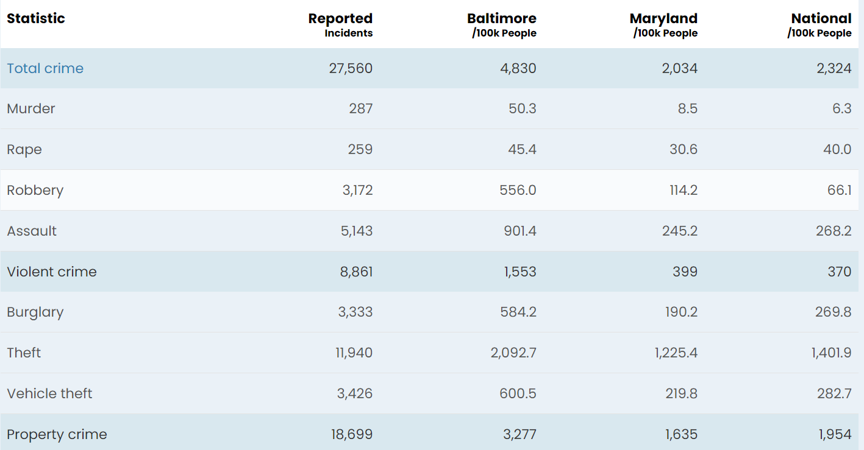

Recommendations to improve city safety for governmental consideration may include the following actions:

1. Police Patrols in High-Call Volume Areas:

The data sets indicate certain neighborhoods, such as downtown Baltimore and Brooklyn, with lots of 911 calls. Such targeted law enforcement efforts in these sectors may be pivotal in combating crime. This should however be done with a community-oriented strategy so as not to appear like a police patrol in a certain community. Community police is when officers engage in forming relationships with citizens. Crime analysts should be employed to continue monitoring and readjusting strategies while increasing patrols during those times that were identified by data.

2. Mental Health and Social Services:

Most emergency calls relate to mental health and social issues. This requires stronger mental health and social support that would free up much-needed resources from police and better meet the specific needs of individual victims of violence. Forming crisis intervention teams that would be composed of licensed mental health professionals whose role would be to attend to 911 calls. Investing money into promoting community mental health resources and work with other social service agencies so that the root causes of the call for police actions like homelessness and substance abuse may be minus.

3. Data-Driven Policing:

The use of data analytics as a means of predictive policing can help in stopping crimes before they happen. However, it should be done ethically so that predictive policing does not become an excuse for biased enforcement and invasion of privacy. Identify trends and possible hotspot areas that can facilitate proactive measures on the based use of data. Promote clear policies and community oversight to make sure data usage is ethical.

In conclusion, our hypothesis proposing specific actions to reduce the crime rate in Baltimore, including population and demographics, serves as the baseline of our analysis. We begin by going through the basic characteristics of 911 calls to show the variation of crime. Next, we go through the call trends throughout the year to see the different crimes caused throughout the months. Furthermore, we go into the neighborhoods with the number of crime calls and the distribution of priority levels within Baltimore. This found that neighborhoods with higher population density had the highest call rate than ones with lower. Following this analysis, we identified the peak hours of arrests and calls per hour as well as the arrest distribution involved. These graphs show similar trends throughout the day showing how the correlation between 911 calls and crime are related to each other. After, we used ArcGIS to create visualizations of the population density and what areas have the highest calls per capita. In this, we see that locations with higher population density have more 911 calls and more crimes. Finally, we run an analysis on how gender and age are correlated with arrests, and individuals between the ages of 20 to 35 constitute a substantial majority, surpassing more than half of the total number of arrests. Besides, data indicates there are four times the difference between gender patterns in the number of arrests. Relating to the hypothesis, some suggestions of actions that the government needs to pay attention to according to the analysis are mental health and social services. Actions include forming crisis intervention teams that would be composed of licensed mental health professionals whose role would be to attend to 911 calls. Also, putting money into promoting community mental health resources and working with other social service agencies so that the root causes of the call for police actions like homelessness and substance abuse can be addressed.

**Bibliography**

Areavibes. “Baltimore, MD Crime.” *Baltimore, MD Crime Rates & Map*, www.areavibes.com/baltimore-md/crime/. Accessed 11 Dec. 2023.

“BPD Arrests.” *Open Baltimore*, data.baltimorecity.gov/datasets/bpd-arrests/explore?location=38.971619%2C-76.515650%2C8.93. Accessed 11 Dec. 2023.

Bureau, United States Census. *Explore Census Data*, data.census.gov/table/ACSDP5Y2020.DP05?q=ZCTA%2Bcensus%2B2020&t=Age%2Band%2BSex. Accessed 11 Dec. 2023.

District, Orleans Parish Communications. “Calls for Service 2022.” *Data.Nola.Gov*, 2023, data.nola.gov/Public-Safety-and-Preparedness/Calls-for-Service-2022/nci8-thrr.

“FBI Releases 2022 Crime in the Nation Statistics.” *FBI*, FBI, 16 Oct. 2023, www.fbi.gov/news/press-releases/fbi-releases-2022-crime-in-the-nation-statistics.

“Part 1 Crime Data.” *Open Baltimore*, data.baltimorecity.gov/datasets/baltimore::part-1-crime-data/explore. Accessed 11 Dec. 2023.

“911 Calls for Service 2021 through Present.” *Catalog*, Publisher Baltimore City, 30 June 2022, catalog.data.gov/dataset/911-calls-for-service-2021-through-present.